Breighel Buggs, ESL Teacher
Alex Green Elementary
(615) 601-4484
Breighel.Buggs@mnps.org
breighelbuggs@gmail.com

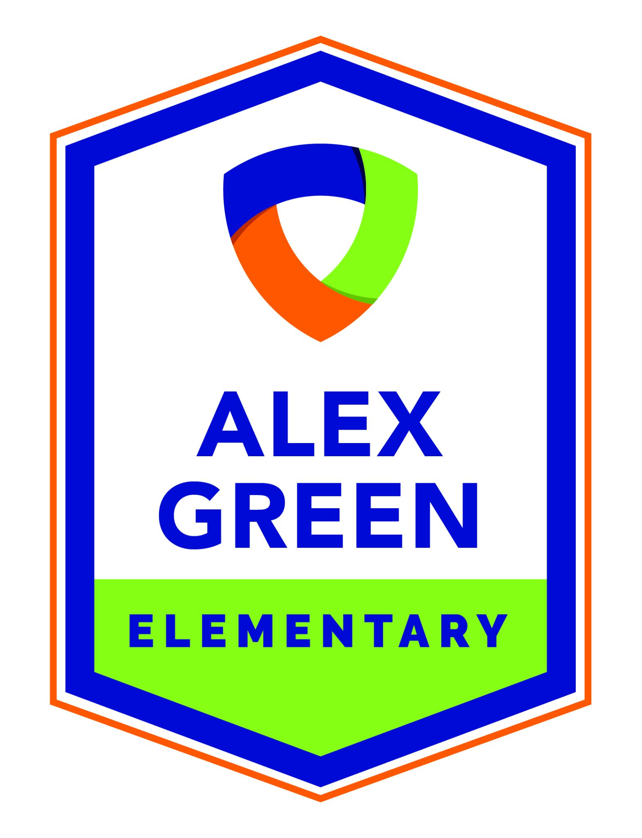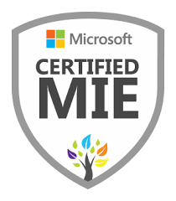

Profile
-Caring and compassionate aspiring educator with over 4 years of experience in ELA and math tutoring.
-Passionate about working with various age groups and deeply committed to enhancing and supporting comprehensive education.
-Fantastic problem-solver and communicator with success in one-on-one teaching and fostering positive learning environments to increase social-emotional health of students.
-Dedicated to clear and thorough communication with students, teachers, and support staff. I am working to help students develop and maintain goal-oriented study habits for consistent academic success.
-Equally skilled at one-on-one and group lessons using adaptable teaching strategies for different types of learners.
-Accustomed to both in-person and online instruction for flexibility and multimedia integration to maximize lesson engagement.
-Apple Teacher and Microsoft Certified

Experience

August 2022 - PRESENT

AVID Institute Leadership Team - School Leadership position
- This is a leadership team for the wonderful Alex Green Elementary school. WICOR strategies!

July 2022 - PRESENT

Project Based Learning Leadership Team - School Leadership position
- I work alongside a few of my co-workers to create project based Learning Lesson Units for the school.

January 2022 - PRESENT

Design Thinking Leadership Team - School Leadership Position
- This is a team of leads for the school teaching how to incorporate Design thinking techniques in the classroom.

January 2022 - PRESENT

Metro Nashville Public Schools, MNPS Support Hub Bransford Avenue - Substitute
- Elementary, middle, and high schools across MNPS.

September 2021 - December 2021

TSBDC INTERNSHIP, Tennessee State - Intern
- Research and Data analysis

August 2018 - May 2020

Work Study, Wesley Foundation - Student Leader
- I enjoyed Sunday service, weekly activities, etc. where I helped with events alongside other student leaders under the leadership of Rev Morton.

August 2018 - May 2021

Butterfly Effect, Wesley Foundation - Student Leader/Facilitator/Volunteer
- Mentor 4th grade girls at Alex Green Elementary. I had the pleasure of building up young girls by discussing self esteem, confidence, hygiene, etc.

August 2020 - May 2022

EdTPA Program, Tennessee State University - Student Teacher
- Highest EdTPA score at TSU
- Student teacher at Robert Churchwell Elementary, Ida B. Wells Elementary, and Beech Elementary

August 2019 - May 2019

After-School Care, Kipp-Kirkpatrick Elementary - Volunteer
- I had a wonderful time volunteering for their After School Care.

August 2022 - Present

Educator, Alex Green Elementary Design Technology Magnet School - ESL Teacher
- I am excited to begin this journey of helping students that are learning English as a Second Language adapt to a new environment in MNPS.

Education

May 2022 - Present

Tennessee State University, 3500 John A. Merritt blvd. Nashville, TN 37209 - Master’s Degree in Educational Technology
- Apple Teacher, Microsoft, Digital literacy, and Digital creator certified

August 2018 - May 2022

Tennessee State University, 3500 John A. Merritt blvd. Nashville, TN 37209 - Bachelor's Degree in Liberal arts and sciences concentration Child Development and Learning (K-8)
- Elementary Education Certification
- Endorsement in ESL PK-12
- Psychology Minor

August 2014 - May 2018

East Nashville Magnet High School, 112 Gallatin Ave, N 11th St, Nashville, TN 37206 - High School Diploma

Reference
Crystal Hicks crystal.hicks@mnps.org
Dr. Kisha Bryan kbryan@tnstate.edu
MaryAngelica Cabler maryangelica.cabler@sumnerschools.org
Dr. Judith Presley jpresley@tnstate.edu
Rev. Michelle Morton 615-818-6312 revmortonwesley@comcast.net
Dr. Nicole Kendall-Arrighi
nkendall@tnstate.edu
Dr. Robbie Melton

